**Update:**

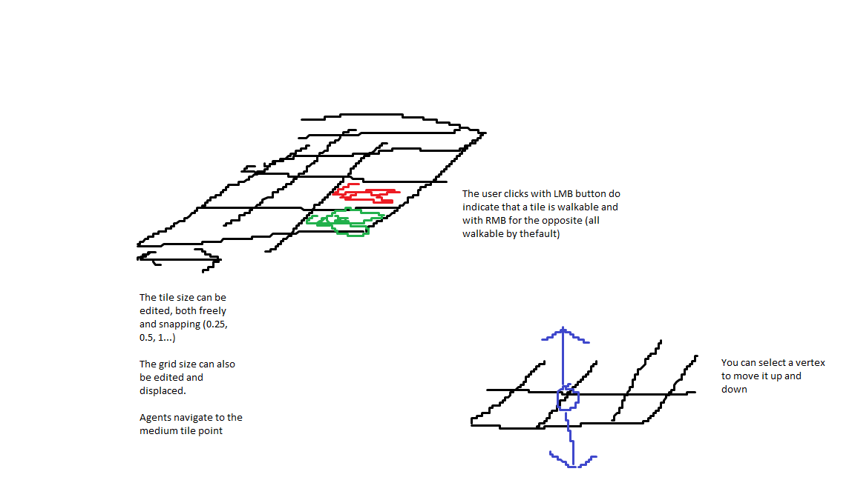

Why couldn't you move a vertex in the other directions?

If you move it up/down, pathfinding will already have to take into account that the distance from another tile to the center of this tile could be anything.

If you can't move it at all, distances between tile centers have only 2 possible values: horizontal/vertical and diagonal.

Also, what about the slopes/ramps that are formed? They should only be accessed from the slope's beginning, but what if only one vertex is lifted upwards? There is a weird slope.

Maybe slopes should only be created by moving two vertices, aka. an edge, up/down

**First Pass:**

The user employs a dropper to tag objects as walls, floors etc (they are then ordered in the hierarchy, as the "Blockout" package).

There should be an algorithm that at the end of the evaluation is able to rotate, scale and displace those walls floors, etc depending on the metrics used to analyse the level.

This process could and should be simplified by making all the rooms and geometry as squares so that a grid can be made.

In this grid each cell is 1x1 Unity meters and it can prove useful for evaluations such as when the controller needs to check for the next most favourable position to handle the enemies (IA .pdf)

Is this too limiting? Can those tiles be created dynamically and thus be irregular? Still, I'd opt for this method because otherwise tile-based decision making and level restructuring would be an odyssey.

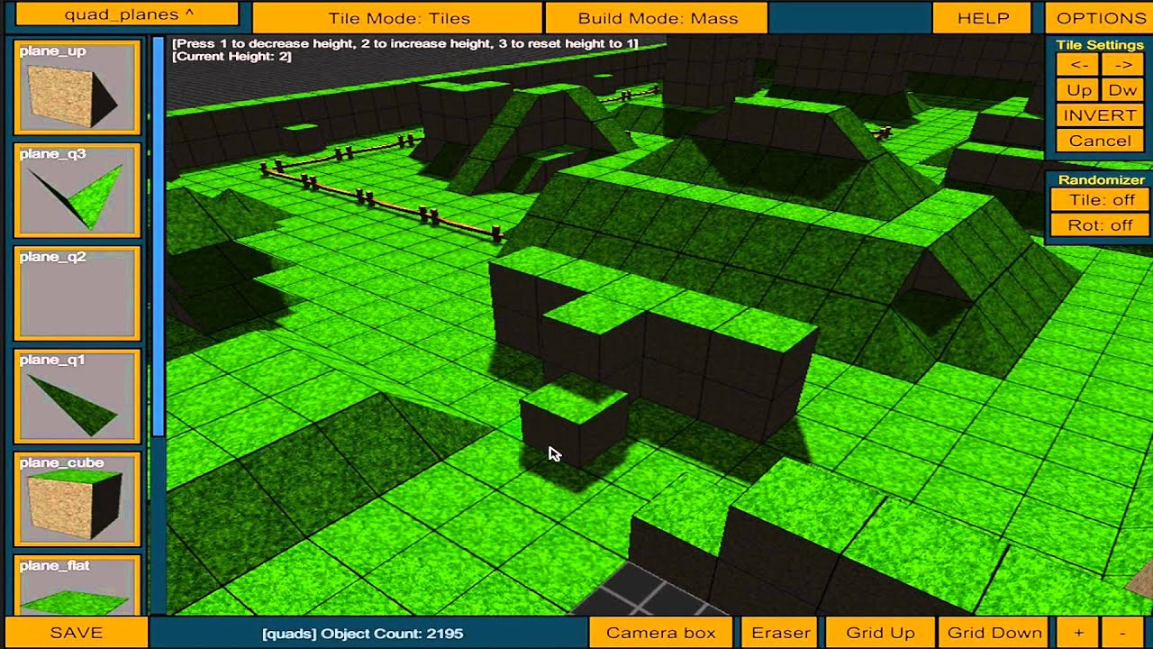

*Protile → paid asset*

With the tile method the user can algo input if there is an item in said tile (which will also affect decision making).

Can we use the navmesh to create a grid? Also:

<https://forum.unity.com/threads/how-to-make-the-nav-mesh-path-not-hug-the-edge.409000/>

Waypoint articles:

(GameDev) <https://www.gamedev.net/articles/programming/artificial-intelligence/navigation-graph-generation-r2805/>

(Unity)

<http://www.trickyfast.com/2017/09/21/building-a-waypoint-pathing-system-in-unity/>

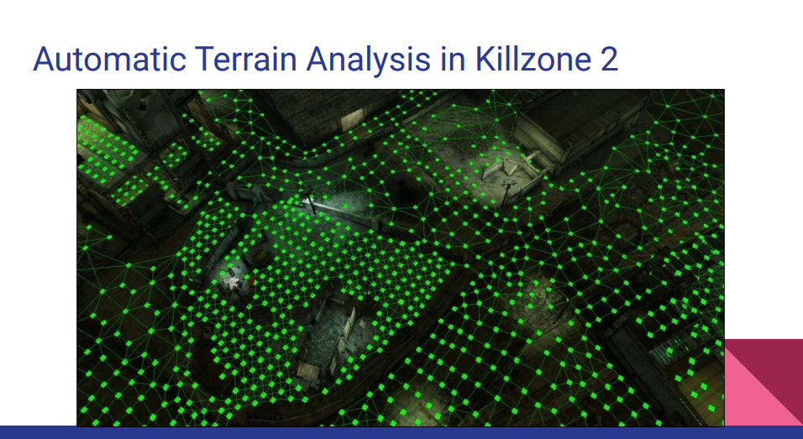

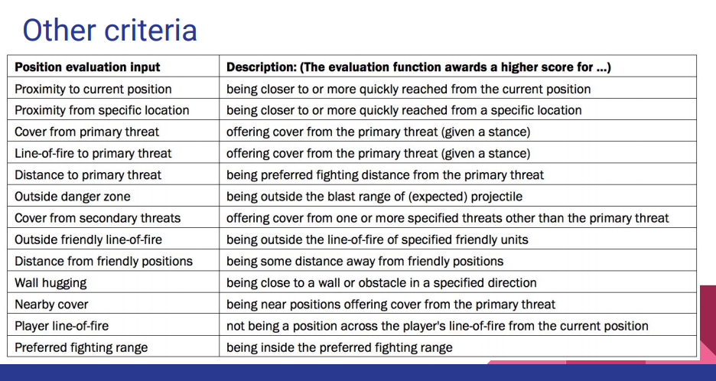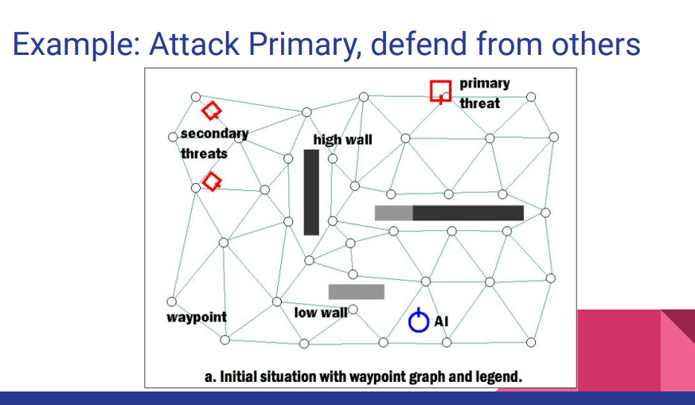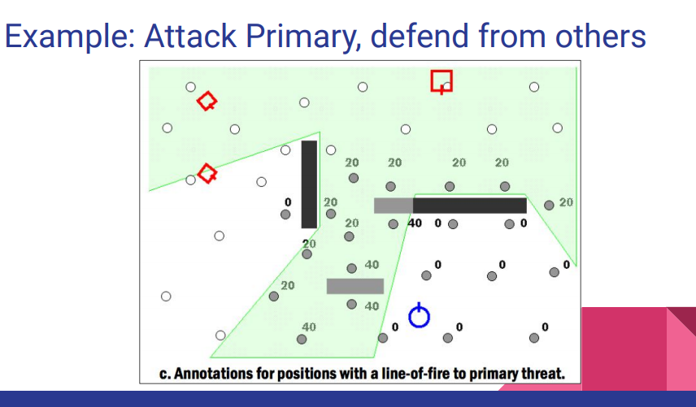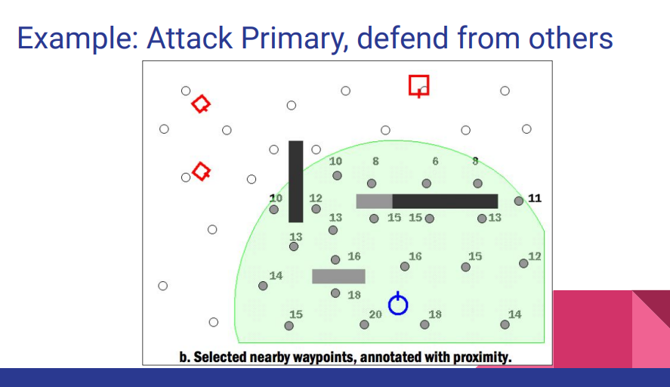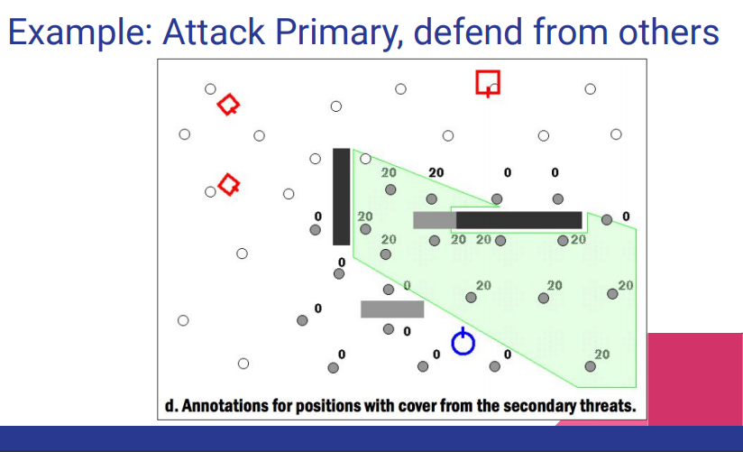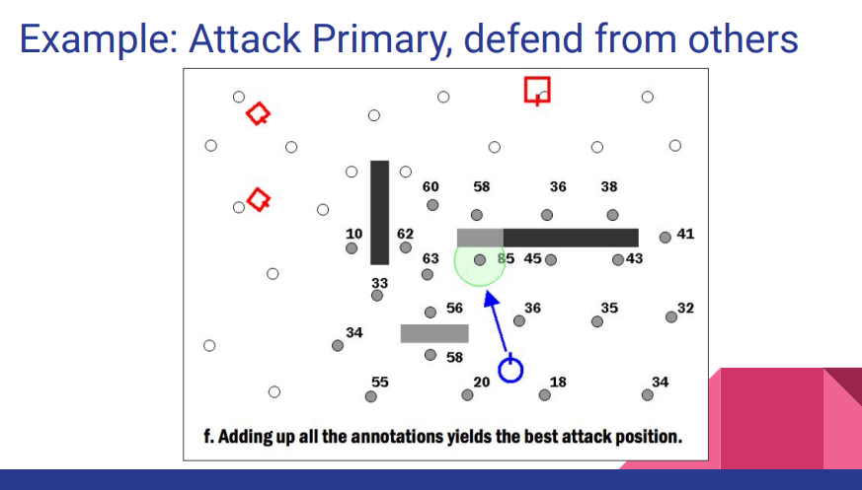

**This is gold:**

